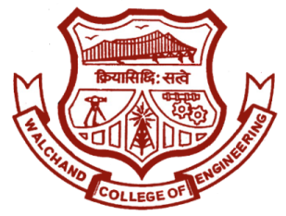

WALCHAND COLLEGE OF ENGINEERING, SANGLI

**ELESA**

**ELECTRONICS ENGINEERING STUDENTS’ ASSOCIATION**

Date:

To

Director,

WCE, Sangli.

**Subject:** Regarding funds for ELECTROVERT 2019 under the “**Lead College Scheme**”

Respected Sir,

ELESA has conducted its mega event “ELECTROVERT 2019” (A state level technical Symposium) on 5th and 6th October, 2019.

ELECTROVERT was comprised of following sub-events:

1. Circuit Builder(N,E) - Circuit building competition

2. Microcket - 8051 & 8085 programming competition

3. Pro-Minance - Circuit design contest in Proteus

4. Trace The Track – Line following competition

5. Buzz-Flip – Management Event

6. Explorica - F.E. special event

7. Prese_Paper - Paper Presentation Competition

8. Quizzical – Quiz Competition

9. The Recruit - Mystery solving competition

10. Electroblitz – Embedded System Designing Competition

11. Funnably – On the spot event

So we request you to consider our application and provide us funds.

Approved by:

Funds sanctioned by: Lead college activity co-ordinator,

**HOD,**

**Dept. Of Electronics**

Dr. B. G. Patil

**Staff Advisor**

Prof. R. G. Mevekari

**President**

Ajit Attarde

**Vice-President**

Vishal Narkhede

**Doodle & A.R.O.**

Dhanraj Bhosale

**Event Director**

Tanvi Magdum

Swati Pawar

**Technical Director**

Vinod Patil

**Club Service Director**

Harshad Ahale

**Aptitude Developer**

Shubhashri Kumbhar

**Editor**

Pranav Gosavi

**Web Developer**

Shivdeep Bisurkar

**Treasurer**

Abhishek Gokhale

**Content Developer**

Amruta Shendure

Email: [walchand.elesa@gmail.com](mailto:walchand.elesa@gmail.com) Website: [www.elesa.co.in](http://www.elesa.co.in)

Mr. R. G. Mevekari

Staff adviser

ELESA

Dr. B. G. Patil

H.O.D. Electronics

Mr. Ajit Attarde

President

ELESA

Dr. B. G. Patil

Dean Student’s welfare

WCE, Sangli

Dr. P. G. Sonavane,

Director,

WCE, Sangli.